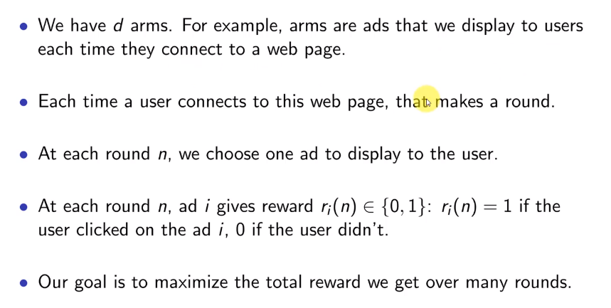Thompson Sampling Intuition – Multi-armed bandit Problem

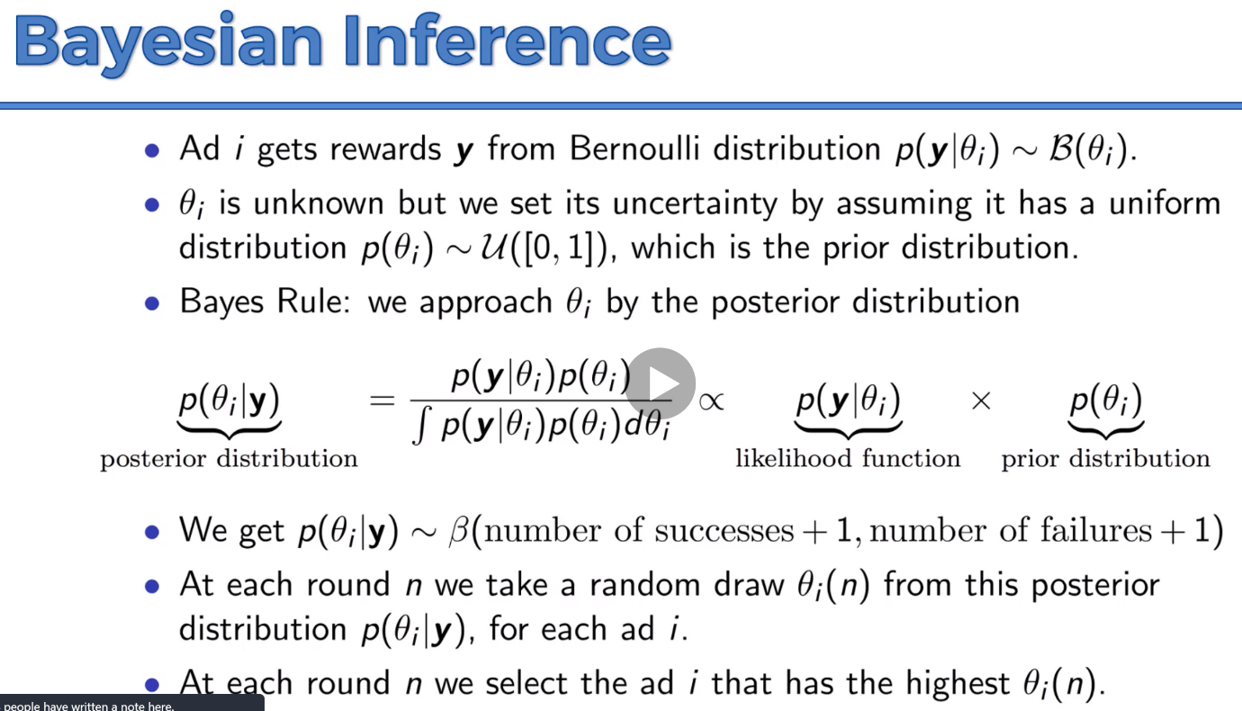Bayesian Inference

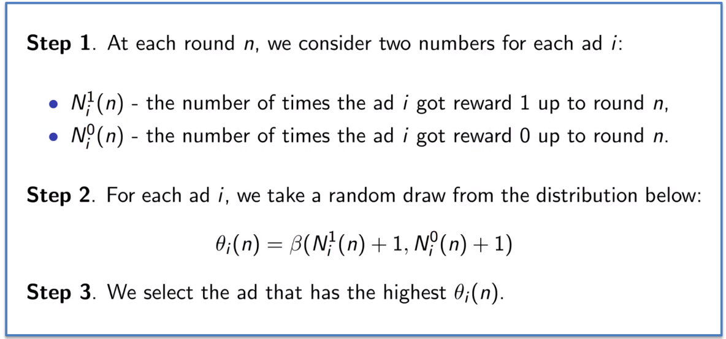Steps:

Thompson Sampling Algorithm – it is Probabilistic Algorithm

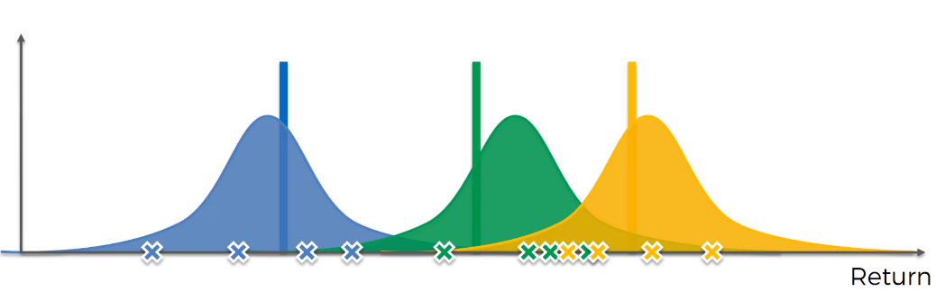You will need a couple trial runs to get the Data and based on the data, the distribution will be constructed.

Construction distribution to where we think the actual expected value might lie. Auxillary mechanism. Where we think the u\* value will be at the peaks.

We are not trying to guess the distributions behind the machines.

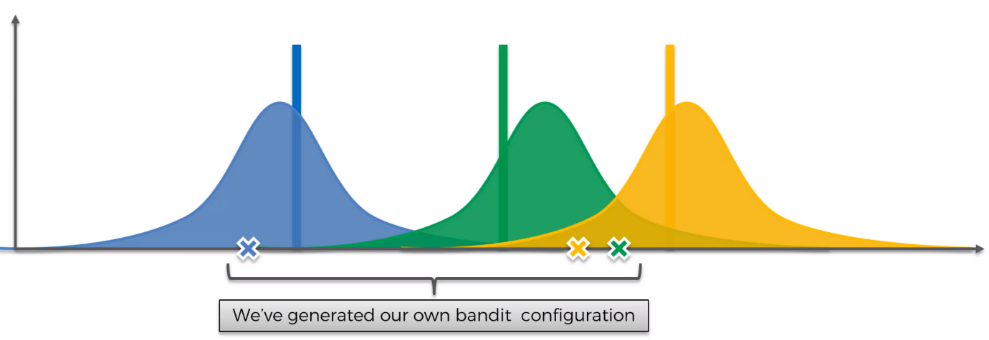Generate your own bandit configuration

And adjust your probability curves based on the best Bandit after the round. And shift the distribution curve.

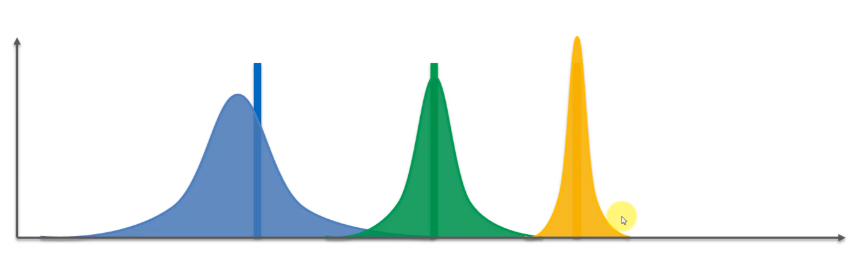At every round, the best Bandit among those 3 will shift their individual distribution curve accordingly